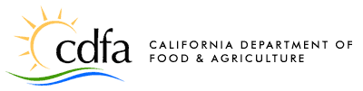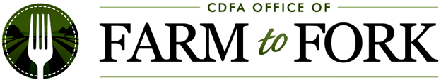

State of California
California Department of Food and Agriculture Office of Farm to Fork (CDFA-F2F)
2022 CALIFORNIA FARM TO SCHOOL INCUBATOR GRANT PROGRAM
Project Work Plan

Project Goal: Based on your Project Narrative, what is the goal – i.e., overarching desired result – of your proposed project?
The goal of this project is to…

Work Plan Table: Please complete the table below and add additional rows as needed. The information below should align with your Project Narrative and Project Goal. For the Timeline column, the grant term is up to 24 months (from 12/1/22 through 11/30/24). For Tracks 1 and 3, the “Performed By” column should include all Project Team members and contractors. For Track 2, the “Performed By” column should include all Project Partners and contractors.
MEASURABLE PROJECT OBJECTIVES  (at least 2 required) | PROJECT ACTIVITIES  (at least 2 per objective) | TIMELINE  (month/year each activity will occur) | PERFORMED BY  (who will implement each activity)
1.
2.

