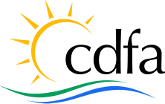 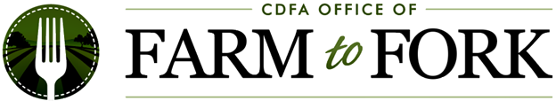

**State of California**

**California Department of Food and Agriculture**

**Office of Farm to Fork**

**Farm to Community Food Hubs Grant Program**

**Track 1 Planning Workplan Template**

**Instructions.** Using this workplan template is required for your Track 1 Farm to Community Food Hubs Program grant application. When submitting all your application materials, please include this completed workplan as a Word document (no PDFs). The table below includes examples for your guidance and should be replaced by your own project workplan details.

The grant term is estimated to be October 2025 – October 2027. Applicants should include a workplan that includes activities within that period. Do not include activities before or after that period.

**Tips and Friendly Reminders**

* “Project goals” give a broad or big picture statement of the overall thing the proposed project aims to accomplish.
* “Objectives” are things that will be measurable or knowable at the end of a project. They are the final results, which together achieve the project goal(s). Objectives provide a more detailed picture of what is to be accomplished. They are similar to goals but are more specific and more focused on timeframes and measurements.
* People reviewing grant applications will be scoring this workplan based on the Track 1 evaluation scoring criteria. Review the evaluation criteria on the [Farm to Community Food Hubs Program website](https://cafarmtofork.cdfa.ca.gov/F2CFHP.html).

*****

*Continue to the next page*

**Project Goal(s):** *Develop a feasibility study that assesses gaps in XY County’s local food infrastructure, needs of food producers to reach larger-scale markets like health clinics, and a business case study with market/financial projections*

|  |  |  |  |
| --- | --- | --- | --- |
| **Objective (Final Result)**  Which objective do the activities on the right help achieve? | **Activity / Task**  List and describe each planned activity/task that helps achieve the objective written on the left. | **Anticipated Timeline**  **(Month / Year)**  Choose informed and realistic timelines within the grant term. Do not include activities before or after the grant term. | **Who will do the work?**  Include project team, partners, and/or contractors when applicable. If hiring new staff or contractors to do the work and they are unknown at this time, write “Staff person to be hired” or “Contractor to be hired” |
| *Hire XYZ Organization as feasibility study contractor* | *Set up meeting with XYZ organization to finalize prices and agreement*  *Finalize agreement with XZY organization and develop detailed plan* | *October 20XX* | *ABC Organization’s Director* |
| *Host 4 farmer listening sessions in X counties to understand gaps in our region* | *Conduct outreach to producers in XYZ region*  *Organize 4 events at A, B, and C Farms*  *Collect and analyze feedback from producers*  *Share results with farmers* | *January – February 20XX* | *ABC Organization’s Project Coordinator*  *XYZ Organization’s Director*  *XYZ Organization’s Coordinator* |
| *Develop 1 business plan including market and financial projections* | *Conduct market research of XY buyers in AB counties*  *Incorporate feedback from food producers to inform pricing and products* | *March 20XX – July 20XX* | *XYZ Organization’s Director*  *XYZ Organization’s Coordinator* |
| *Develop final feasibility study* | *Incorporate business plan and other findings from outreach*  *Finalize mapping of local food infrastructure in XYZ counties.*  *Ask GHJ organization to review and provide input.*  *Conduct monthly reviews and edits to finalize details* | *October 20XX – December 20XX* | *ABC Organization’s Director*  *XYZ Organization’s Director*  *XYZ Organization’s Coordinator* |
|  |  |  |  |
|  |  |  |  |
|  |  |  |  |